**RAJALAKSHMANAN C**

**E0219054**

**1.pwd command**

Use the **pwd** command to find out the path of the current working directory (folder) you’re in.

### 2. cd command

To navigate through the Linux files and directories, use the **cd** command.



**3.cd ..**

(with two dots) to move one directory up

**4.cd**

to go straight to the home folder

**5.cd –**

(with a hyphen) to move to your previous directory

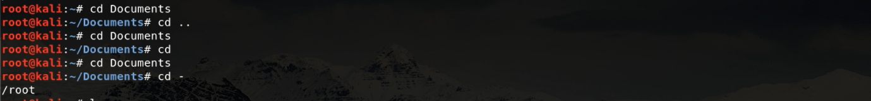

### 6. ls command

### The**ls** command is used to view the contents of a directory.

**7.ls -R**

will list all the files in the sub-directories as well

**8.ls -a**

will show the hidden files

**9.ls -al**

will list the files and directories with detailed information like the permissions, size, owner, etc.

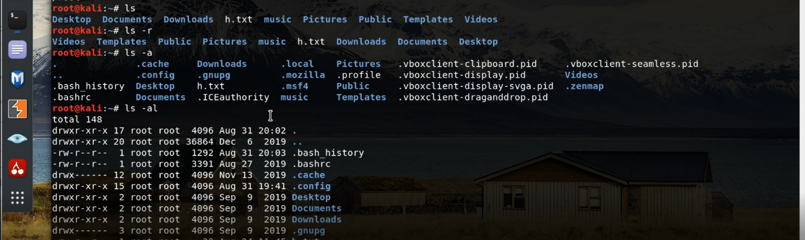

### 10. cat command

### It is used to list the contents of a file on the standard output (sdout).

### 11. mkdir command

### Use **mkdir** command to make a new directory — if you type **mkdir Music** it will create a directory called **Music**.

### 12. rmdir command

### The **rm** command is used to delete directories and the contents within them.

### 13. touch command

### The **touch** command allows you to create a blank new file through the Linux command line.

### 14.  locate command

### You can use this command to **locate** a file, just like the search command in Windows

### 

### 15. find command

### Similar to the **locate** command, using **find** also searches for files and directories.

### 16. grep command

### It lets you search through all the text in a given file.

### 17.  sudo command

### Short for “**SuperUser Do**”, this command enables you to perform tasks that require administrative or root permissions.

### 18.  df command

### Use **df** command to get a report on the system’s disk space usage, shown in percentage and KBs.

### 19. du command

### If you want to check how much space a file or a directory takes, the **du** (Disk Usage) command is the answer.

### 

### 20.  head command

### The**head** command is used to view the first lines of any text file.

### 21. tail command

### This one has a similar function to the head command, but instead of showing the first lines, the **tail** command will display the last ten lines of a text file.

### 22. diff command

### Short for difference, the **diff** command compares the contents of two files line by line

### 23. tar command

### The **tar** command is the most used command to archive multiple files into a **tarball** — a common Linux file format that is similar to zip format

### 24. jobs command

### **jobs** command will display all current jobs along with their statuses.

### 

### 25. kill command

### If you have an unresponsive program, you can terminate it manually by using the **kill** command.

### 26.  ping command

### the command will check whether you’re able to connect to Google and also measure the response time.

### 27. wget command

### you can even download files from the internet with the help of the **wget** command.

### 28. uname command

### will print detailed information about your Linux system like the machine name, operating system, kernel,

### 29. top command

### the **top** command will display a list of running processes and how much CPU each process uses.

### 30. history command

### As such, running **history** command is particularly useful if you want to review the commands you’ve entered before.

### 

### 31. man command

### entering **man tail** will show the manual instruction of the tail command.

### 

### 32. echo command

### This command is used to move some data into a file.

### would type **echo Hello, my name is raja** **>> name.txt**

### **33.** zip, unzip command

### Use the **zip** command to compress your files into a zip archive, and use the **unzip** command to extract the zipped files from a zip archive.

### 

### 

### 34. hostname command

### If you want to know the name of your host/network simply type **hostname**. Adding a **-I** to the end will display the IP address of your network.

### 35.  useradd, userdel command

### **useradd** is used to create a new user, while **password** is adding a password to that user’s account. To add a new person named RAJA type, **useradd John** and then to add his password type, **passwd 123456789.**

### To remove a user is very similar to adding a new user. To delete the users account type, **userdel UserName**

### 

### 